To: Dr. William Hecker

CC: Troy Holland

From: Adriaan Riet

Subject: Shell and Tube Heat Exchanger Recommendations

## Introduction

In response to your request that we analyze the heat exchanger in the UO Lab, we have done an in-depth analysis and have a recommendation for a heat exchanger, based on a calculated fouling resistance as a function of cooling water flow rate and steam pressure. We have also selected a one pass Unit #8048 with a ¼” pipe diameter as the cheapest heat exchanger capable of 200 gallons per minute (gpm) flow at 100 gauge psi (psig) steam.

## Apparatus Design

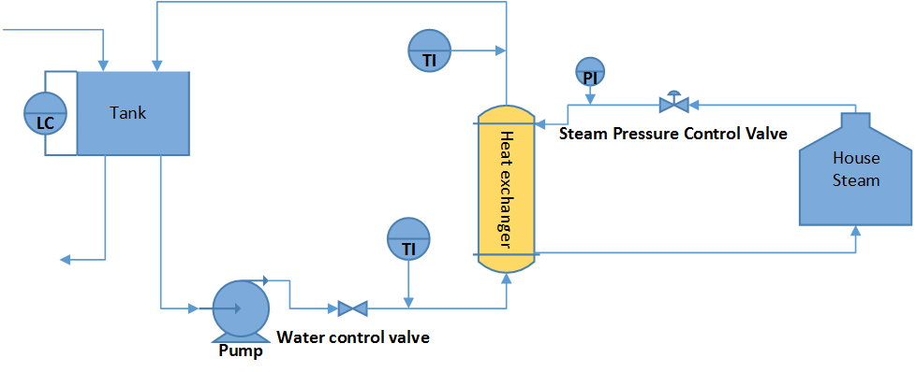Figure 1 shows the heat basic setup of the heat exchanger apparatus. Water was poured into a stirred tank. The mixed water was pumped through a 2" steel pipe through a flow controller to the inlet of the tube side of the shell and tube heat exchanger (SSCF model 03024, narrow baffle spacing). Steam was brought in at around 54 psig, and its pressure was reduced by a pressure control valve. This saturated steam was then run through the shell side of the heat exchanger before being discarded. The outlet water from the heat exchanger was poured back into the tank, which was drained continuously to prevent overfilling. Two temperature indicators and a pressure indicator were installed as shown on Figure 1.

Figure 1: Apparatus

## Experimental Procedure

Table 1 shows the flow and pressure conditions that we used in our data set. These conditions were chosen because they spanned the range of steam pressures and flow rates we could safely achieve in the lab without damaging equipment. The run at 20 psi gauge and 38 gallons per minute was used as a test before we created the rest of the matrix, but still contains valid data.

Table 1: flow and pressure conditions

|  |  |  |  |  |  |
| --- | --- | --- | --- | --- | --- |
| Flow/Pressure | 15 psig | 20 psig | 25 psig | 35 psig | 45 psig |
| 25 gpm | X |  | X | X | X |
| 30 gpm | X |  | X | X | X |
| 35 gpm | X |  | X | X | X |
| 38 gpm |  | X |  |  |  |
| 40 gpm | X |  | X | X | X |
| 45 gpm | X |  | X | X | X |
| 50 gpm | X |  | X | X | X |

To start up the process, we first flowed water through the heat exchanger, then added steam. We began recording data only after the outlet water temperature was no longer increasing. We recorded 200 data points at one second intervals at each flow condition before moving to the next conditions. We did not randomize this experiment because of the long settling times of our system. This sacrifice allowed us to record more data.

## Theory and Data

Heat exchangers are commonly used in industry, and the theoretical understanding of their function is well developed. We used Equation 1 for our overall heat transfer equation, with $UA$ defined in Equation 2. Here $\dot{m}$ is the mass flow rate, $Q$ is the magnitude of heat transferred, $ΔT$ is the difference between inlet and outlet temperatures of the cooling water streams, $UA$ is an overall heat transfer coefficient, and $LMTD$ is the log-mean temperature difference[1]. In Equation 2, $R$ is the fouling factor, $A_{i}$ and $A_{o}$ are the inner and outer surface areas of the pipes in the heat exchanger, $D_{i}$ and $D_{o}$ are the inner and outer diameters of individual pipes within the heat exchanger and $h_{i}$ and $h_{o}$ are the convection coefficients for the flow in the tube and on the shell side respectively. We also used the thermal conductivity of steel, $k_{steel}$.

|  |  |  |
| --- | --- | --- |
|  | $$Q= \dot{m}C_{p}ΔT=UA⋅LMTD$$ | (1) |
|  | $$\frac{A_{i}}{UA}=R⋅A_{i}+\frac{1}{h_{i}}+\frac{\ln\left(\frac{D_{o}}{D_{i}}\right)}{2πk_{steel}}+\frac{A_{i}}{h_{o}A_{o}}$$ | (2) |

To determine convection coefficients, we used the correlations given in Equation 3and Equation 4[2]. Here, is the Nusselt number, $Re$ is the Reynolds' number, and $Pr$ is the Prandtl number. In Equation 4, $ρ_{l}$ and $ρ_{v}$ are the liquid and vapor densities of the steam, ${h'}_{fg}$ is the adjusted heat of vaporization (see Equation 5), $T_{sat}$ and $T_{surface}$ are the steam temperatures of the saturated steam and at the outer surface of the pipe respectively. The viscosity of the condensed steam is $μ_{l}$, and its thermal conductivity is $k_{l}$. The heat of vaporization at steam conditions is given by $h_{fg}$ and the heat capacity of the liquid steam is given by $c_{p,l}$. All properties in the cooling stream are assumed to be at the average water temperature, and all properties in the steam are assumed to be that of the saturated liquid or vapor.

|  |  |  |
| --- | --- | --- |
|  | $${Nu}_{inner}=\frac{hD_{i}}{k_{water}}=0.023{Re}^{\frac{4}{5}}{Pr}^{0.4}$$ | (3) |
|  | $${Nu}_{outer}=\frac{h_{outer}L}{k_{l}}=0.943{\left[\frac{ρ_{l}g\left(ρ_{l}-ρ_{v}\right){h^{'}}_{fg}L^{3}}{μ_{l}k_{l}\left(T_{sat}-T_{surface}\right)}\right]}^{\frac{1}{4}}$$ | (4) |
|  | $${h'}_{fg}=h_{fg}+0.68c_{p,l}(T_{sat}-T_{surface})$$ | (5) |

We used the steam tables[3] to get the properties of the steam and water. Atmospheric pressure was assumed when calculating the properties of the cold stream. We calculated the temperature of the outer surface of the pipe iteratively. We used manufacturer specifications[4] for the diameter of the pipes, number of tubes, baffle spacing and overall unit length.

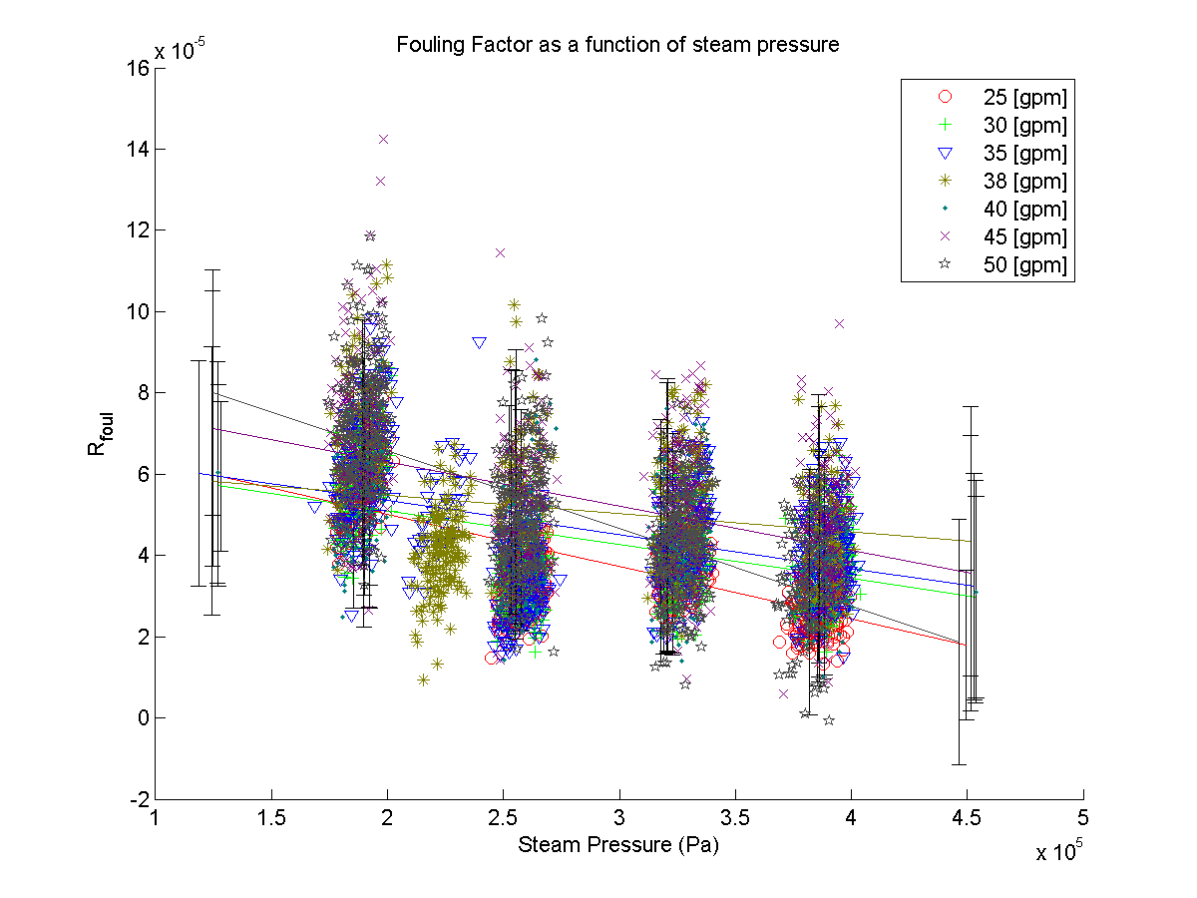Once the fouling factor was calculated for each datum, we plotted fouling factor as a function of flow rate and steam pressure in order to predict the fouling factor of a heat exchanger with 200 gpm flow cooling water at 100 and 300 psi gauge pressure steam. We found a positive correlation between the fouling factor and the flow rate of cold stream (see Figure 2), however this correlation was not statistically significant at the 95% level. On the other hand, we found a negative correlation between steam pressure and the fouling factor, which was shown to be statistically significant (α=.9999). Because we were unable to test flow rates and steam pressures near the design value, we extrapolated the extreme case of the highest predicted fouling factor by ignoring the effects of steam pressure on fouling factor and using the upper end of our 95% confidence interval of fouling factor as the true value.

Figure 2: Fouling Factor as a function of steam pressure

We also calculated the fouling factors necessary to achieve the heat transfer required in the problem statement for each stainless steel heat exchanger offered by Standard Exchange (our vendor). We compared these fouling factors with the fouling factor that we calculated for the design conditions, and obtained the results in Table 2 (see Conclusions & Recommendations). We obtained the same results using a fit of cooling water velocity versus fouling factor for each heat exchanger.

## Sources of Error

It should be noted that there is no reason a fouling factor under these conditions should be accurate in determining the fouling factor of the design specifications. It was also shown that fouling factor is a function of steam pressure, which was ignored. The errors in our projection are likely to lower the fouling factor and allow smaller heat exchangers to be used than our recommendation allows.

These are estimates only, and more tests should be done closer to the design conditions to ensure the validity of our calculations. Also, while the manufacturer only recommends regarding wide baffle spacing heat exchangers for these design conditions, the heat exchanger we used had narrow baffle spacing, and the flow pattern will probably be different for the wide baffle spaced heat exchanger, so there is much less confidence in our baffle recommendations.

## Conclusions & Recommendations

The smallest heat exchanger capable of the required heat transfer was #8048 in ¼ inch pipe with a wide baffle spacing. We recommend this heat exchanger. We also recommend running at 100 psi gauge steam, or contacting the manufacturer for a heat exchanger that is rated for 300 psi gauge, as the manufacturer only recommends running these at 225 psi. The narrow baffle spacing was not recommended because Standard Exchange lists the maximum flow rate for narrow baffle spacing at 180 gpm. Table 2 lists the models capable of the heat transfer, their specifications, and the maximum allowable fouling factor they can have in order to achieve the heat transfer required.

Table 2: Heat Exchangers That Will Work at 100 Psig

|  |  |  |  |  |
| --- | --- | --- | --- | --- |
| Model Number | Pipe Diameter | Baffle Spacing | Fouling Factor | Cost |
| 8048 | 0.25" | Wide | 0.000153 | $10,243.00 |
| 8060 | 0.25" | Wide | 0.000249 | $11,653.00 |
| 8072 | 0.25" | Wide | 0.000343 | $13,071.00 |
| 8084 | 0.25" | Wide | 0.000436 | $14,488.00 |
| 8096 | 0.25" | Wide | 0.000529 | $15,904.00 |
| 8060 | 0.375" | Wide | 8.35E-05 | $11,653.00 |
| 8072 | 0.375" | Wide | 0.000156 | $13,071.00 |
| 8084 | 0.375" | Wide | 0.000227 | $14,488.00 |
| 8096 | 0.375" | Wide | 0.000297 | $15,904.00 |

## Appendix

The combined effects of steam pressure and cooling water velocity on fouling factor, Figure 3.

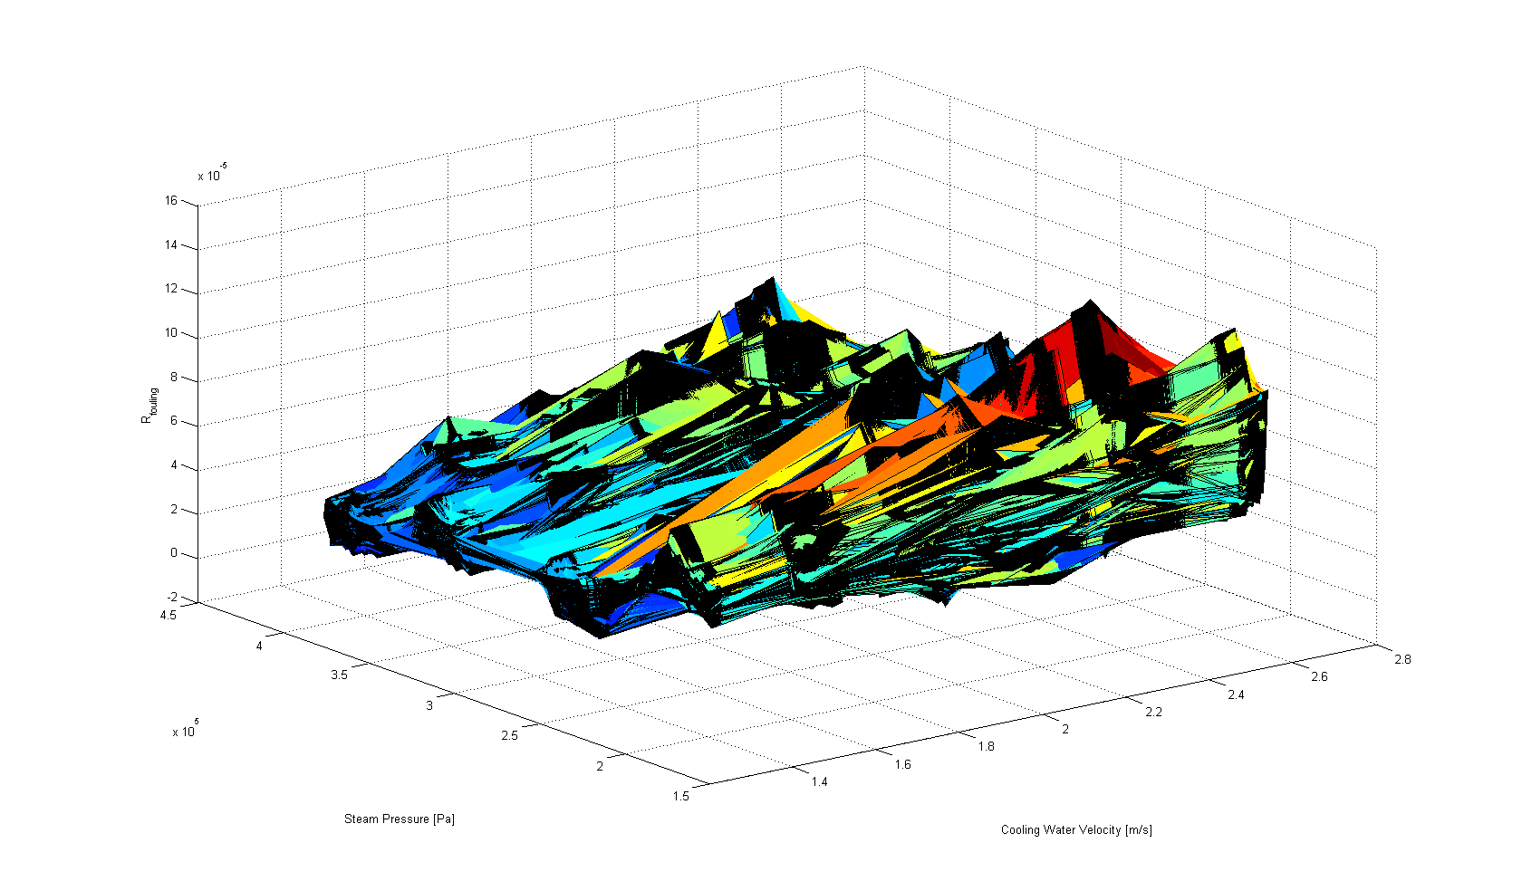

Figure 3

## Acknowledgements

I would like to thank Loren Anderson, Austin Smith, Colton Hickman and Heather Riet for their excellent critiques of this memorandum.

# Bibliography

Bergman, T. L., Lavine, A. S., Incropera, F. P., & Dewitt, D. P. (2011). *Fundamentals of Heat and Mass Transfer, 7th Edition.* Jefferson City: John Wiley & Sons, Inc.

Standard Xchange. (2014, September). *SSCF Stainless Steel Heat Exchangers*. Retrieved from standard-xchange.com.

*X Steam, Thermodynamic properties of water and steam*. (2006, August 01). Retrieved from Matlab Central: http://www.mathworks.com/matlabcentral/fileexchange/9817-x-steam--thermodynamic-properties-of-water-and-steam

1. See (Bergman, Lavine, Incropera, & Dewitt, 2011, p. 714)
2. (Bergman, Lavine, Incropera, & Dewitt, 2011, pp. 544,678), Equation 5 is also on page 678.
3. (X Steam, Thermodynamic properties of water and steam, 2006)
4. (Standard Xchange, 2014)